**BANK LOAN REPORT QUERY DOCUMENT**

1. **SUMMARY - BANK LOAN REPORT**

* **KPI’s:**
* **Total Loan Applications:**

SELECT COUNT(id) AS Total_Applications

FROM bank_loan_data;



* **MTD Loan Applications:**

SELECT COUNT(id) AS Total_Applications

FROM bank_loan_data

WHERE MONTH(issue_date) = 12



* **PMTD Loan Applications:**

SELECT COUNT(id) AS Total_Applications

FROM bank_loan_data

WHERE MONTH(issue_date) = 11



* **Total Funded Amount:**

SELECT SUM(loan_amount) AS Total_Funded_Amount

FROM bank_loan_data



* **MTD Total Funded Amount:**

SELECT SUM(loan_amount) AS Total_Funded_Amount

FROM bank_loan_data

WHERE MONTH(issue_date) = 12



* **PMTD Total Funded Amount:**

SELECT SUM(loan_amount) AS Total_Funded_Amount

FROM bank_loan_data

WHERE MONTH(issue_date) = 11



* **Total Amount Received:**

SELECT SUM(total_payment) AS Total_Amount_Collected

FROM bank_loan_data



* **MTD Total Amount Received:**

SELECT SUM(total_payment) AS Total_Amount_Collected

FROM bank_loan_data

WHERE MONTH(issue_date) = 12



* **PMTD Total Amount Received:**

SELECT SUM(total_payment) AS Total_Amount_Collected

FROM bank_loan_data

WHERE MONTH(issue_date) = 11



* **Average Interest Rate:**

SELECT AVG(int_rate)*100 AS Avg_Int_Rate

FROM bank_loan_data



* **MTD Average Interest:**

SELECT AVG(int_rate)*100 AS MTD_Avg_Int_Rate

FROM bank_loan_data

WHERE MONTH(issue_date) = 12



* **PMTD Average Interest:**

SELECT AVG(int_rate)*100 AS PMTD_Avg_Int_Rate

FROM bank_loan_data

WHERE MONTH(issue_date) = 11



* **Average DTI:**

SELECT AVG(dti)*100 AS Avg_DTI

FROM bank_loan_data



* **MTD Average DTI:**

SELECT AVG(dti)*100 AS MTD_Avg_DTI

FROM bank_loan_data

WHERE MONTH(issue_date) = 12



* **PMTD Average DTI:**

SELECT AVG(dti)*100 AS PMTD_Avg_DTI

FROM bank_loan_data

WHERE MONTH(issue_date) = 11



**GOOD LOAN ISSUED:**

* **Good Loan Percentage:**

SELECT

(COUNT(CASE WHEN loan_status = 'Fully Paid' OR loan_status = 'Current' THEN id END) * 100.0) / COUNT(id) AS Good_Loan_Percentage

FROM bank_loan_data;



* **Good Loan Applications:**

SELECT COUNT(id) AS Good_Loan_Applications

FROM bank_loan_data

WHERE loan_status = 'Fully Paid' OR loan_status = 'Current'



* **Good Loan Funded Amount:**

SELECT SUM(loan_amount) AS Good_Loan_Funded_amount

FROM bank_loan_data

WHERE loan_status = 'Fully Paid' OR loan_status = 'Current'



* **Good Loan Amount Received:**

SELECT SUM(total_payment) AS Good_Loan_amount_received

FROM bank_loan_data

WHERE loan_status = 'Fully Paid' OR loan_status = 'Current'



**BAD LOAN ISSUED:**

* **Bad Loan Percentage:**

SELECT

(COUNT(CASE WHEN loan_status = 'Charged Off' THEN id END) * 100.0) / COUNT(id) AS Bad_Loan_Percentage

FROM bank_loan_data;



* **Bad Loan Applications:**

SELECT COUNT(id) AS Bad_Loan_Applications

FROM bank_loan_data

WHERE loan_status = 'Charged Off'



* **Bad Loan Funded Amount:**

SELECT SUM(loan_amount) AS Bad_Loan_Funded_amount

FROM bank_loan_data

WHERE loan_status = 'Charged Off'



* **Bad Loan Amount Received:**

SELECT SUM(total_payment) AS Bad_Loan_amount_received

FROM bank_loan_data

WHERE loan_status = 'Charged Off'



* **Loan Status:**

SELECT

loan_status,COUNT(id) AS LoanCount,SUM(total_payment),Total_Amount_Received,

SUM(loan_amount) AS Total_Funded_Amount,AVG(int_rate * 100) AS Interest_Rate,AVG(dti * 100) AS DTI

FROM bank_loan_data

GROUP BY loan_status;

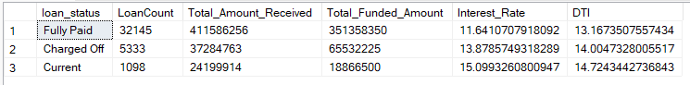

SELECT

loan_status, SUM(total_payment) AS MTD_Total_Amount_Received,

SUM(loan_amount) AS MTD_Total_Funded_Amount

FROM bank_loan_data

WHERE MONTH(issue_date) = 12

GROUP BY loan_status

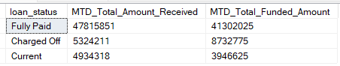

1. **OVERVIEW - BANK LOAN REPORT**

* **MONTH**

SELECT

MONTH(issue_date) AS Month_Munber,

DATENAME(MONTH, issue_date) AS Month_name,

COUNT(id) AS Total_Loan_Applications,

SUM(loan_amount) AS Total_Funded_Amount,

SUM(total_payment) AS Total_Amount_Received

FROM bank_loan_data

GROUP BY MONTH(issue_date), DATENAME(MONTH, issue_date)

ORDER BY MONTH(issue_date)

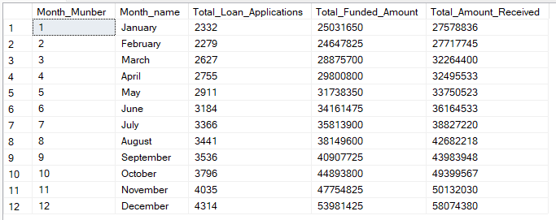

* **STATE**

SELECT

address_state AS State,

COUNT(id) AS Total_Loan_Applications,

SUM(loan_amount) AS Total_Funded_Amount,

SUM(total_payment) AS Total_Amount_Received

FROM bank_loan_data

GROUP BY address_state

ORDER BY address_state

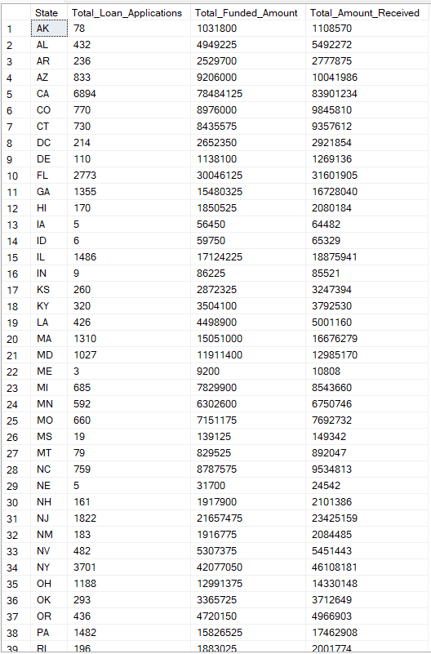

* **TERM**

SELECT

term AS Term,

COUNT(id) AS Total_Loan_Applications,

SUM(loan_amount) AS Total_Funded_Amount,

SUM(total_payment) AS Total_Amount_Received

FROM bank_loan_data

GROUP BY term

ORDER BY term

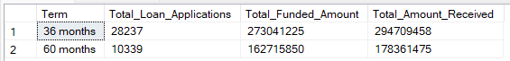

* **EMPLOYEE LENGTH**

SELECT

emp_length AS Employee_Length,

COUNT(id) AS Total_Loan_Applications,

SUM(loan_amount) AS Total_Funded_Amount,

SUM(total_payment) AS Total_Amount_Received

FROM bank_loan_data

GROUP BY emp_length

ORDER BY emp_length

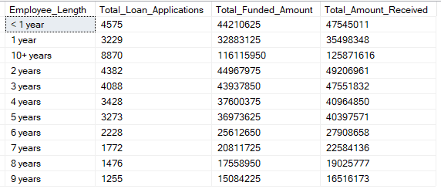

* **PURPOSE**

SELECT

purpose AS PURPOSE,

COUNT(id) AS Total_Loan_Applications,

SUM(loan_amount) AS Total_Funded_Amount,

SUM(total_payment) AS Total_Amount_Received

FROM bank_loan_data

GROUP BY purpose

ORDER BY purpose

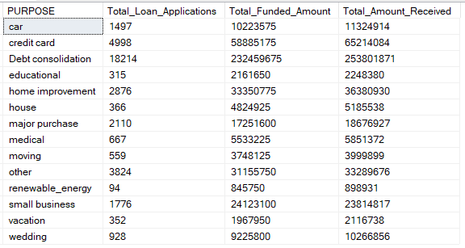

* **HOME OWNERSHIP**

SELECT

home_ownership AS Home_Ownership,

COUNT(id) AS Total_Loan_Applications,

SUM(loan_amount) AS Total_Funded_Amount,

SUM(total_payment) AS Total_Amount_Received

FROM bank_loan_data

GROUP BY home_ownership

ORDER BY home_ownership

